Project Design Phase-II
Data Flow Diagram & User Stories

Date | 22 January 2026
Team ID | LTVIP2026TMIDS87961
Project Name | Educational Organisation Using ServiceNow
Maximum Marks | 4 Marks

Data Flow Diagrams:
A Data Flow Diagram (DFD) is a traditional visual representation of the information flows within a system. A neat and clear DFD can depict the right amount of the system requirement graphically. It shows how data enters and leaves the system, what changes the information, and where data is stored.

Example: (Simplified)

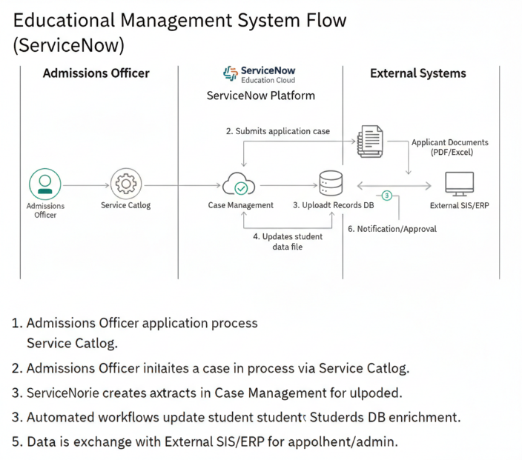

User Stories
Use the below template to list all the user stories for the product.
User Type | Functional Requirement (Epic) | User Story Number | User Story / Task | Acceptance Criteria | Priority | Release
Student | Registration | USN-1 | As a student, I can register by entering my personal and academic details | Student account is created and dashboard is accessible | High | Sprint-1
Student | Login | USN-2 | As a student, I can log in using my credentials | Student can securely access student portal | High | Sprint-1
Student | Profile Management | USN-3 | As a student, I can view and update my profile | Profile updates are saved successfully | Medium | Sprint-2
Student | Progress Tracking | USN-4 | As a student, I can view my grades and progress reports | Reports are visible with latest data | High | Sprint-2
Teacher | Registration | USN-5 | As a teacher, I can register and create my professional profile | Teacher profile is created and accessible | High | Sprint-1
Teacher | Student Management | USN-6 | As a teacher, I can view student details and academic records | Teacher can access assigned students data | High | Sprint-2
Teacher | Performance Update | USN-7 | As a teacher, I can update student grades and feedback | Updated records are reflected in system | High | Sprint-2
Admin | Admission Management | USN-8 | As an admin, I can manage student admission applications | Admin can approve or reject applications | High | Sprint-1
Admin | User Management | USN-9 | As an admin, I can manage student and teacher accounts | Admin can create, edit, or deactivate accounts | High | Sprint-1
Admin | Reports & Analytics | USN-10 | As an admin, I can generate institutional reports | Reports can be downloaded and viewed | Medium | Sprint-3
Administrator | System Configuration | USN-11 | As an administrator, I can configure workflows in ServiceNow | Workflows execute as configured | Medium | Sprint-3
Customer Care / Support | Issue Management | USN-12 | As support staff, I can track and resolve user issues | Tickets can be created, assigned, and resolved | Medium | Sprint-2

